Nicholas Skinner

CS453

Spring 2019

**Project #1 - Simple Grayscale Point Cloud**

**Final Assignment Images:**

Below are a series of images to display my assignment submission. A grayscale point cloud with 4 seperate heat locations. I tried to show them all off through the images, as well as displaying the other assignment requirements (name in title, etc…)

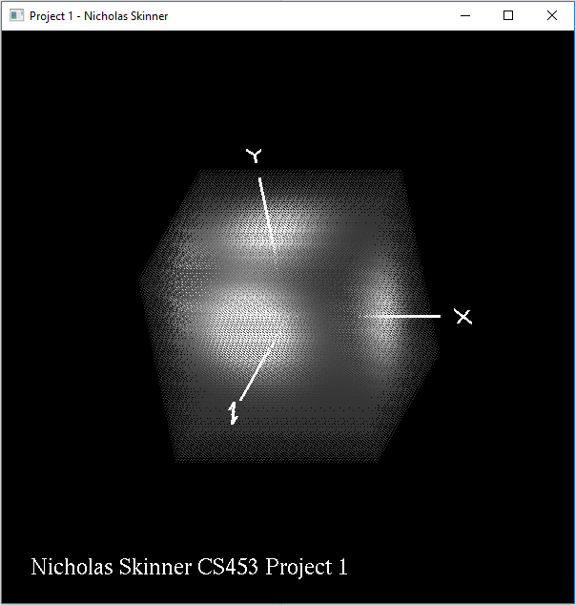

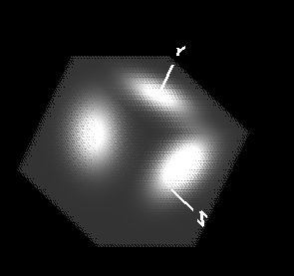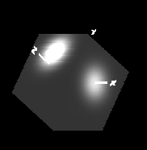

**Review:**

This was a good assignment to ease into the visualization process, applying a function to a point cloud was a good and easy way to immerse myself back into OpenGL programming. It was easy enough to pretty much insert the provided content into the sample solution, little thinking was needed outside of ensuring the Visual Studio installs and packages were set up correctly.

I’m not traditionally comfortable with structs within C++, but I’m trying to push myself to use them more. Considering the assignment compiled, ran and looked correct, I’d like to think that I managed to use them properly!

Video was not required for this submission, so one was not recorded.